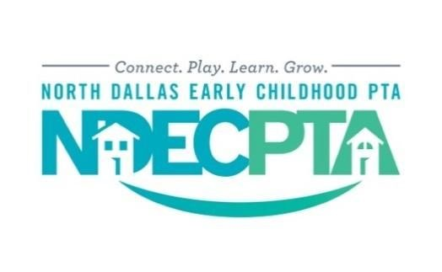

Dear Neighborhood Business,

The North Dallas Early Childhood PTA is a vibrant, non­profit organization comprised of over 300 active and energetic families ​with preschoolers who live in the surrounding area. We connect local families via play groups, informative programs, community service outreach and events throughout the year.

Our group publishes a monthly ​newsletter​ which highlights local businesses, special events, upcoming activities and community news. We also have a very active private Facebook page and our website, www.ndecpta.org, which both serve as online informational hubs for our members. Here we list activities for parents and children and consistently connect our members to our sponsors.

Our network of families is strong and, as our reach continues to grow each year, we would love to serve as a referral base for your business. Listed below are the different sponsorship levels and details on the offerings at each level:

SPONSORSHIP LEVEL | Sponsor Benefits | One-Time Donation
SILVER | - Business link and logo on NDECPTA.com​ and link in our newsletter (published September 2017-August 2018)  - Promotions may be emailed to the sponsorship chair (ndecptaadvertising@gmail.com) and will be posted on our Facebook page (up to twice a month) | $150
GOLD | - Business link and logo on NDECPTA.com​ and link in our newsletter (published September 2017-August 2018)  - Promotions may be emailed to the sponsorship chair (ndecptaadvertising@gmail.com) and will be posted on our Facebook page (up to twice a month)  - Business logo on the back of our member t­shirts (which are worn at our events in the community and around town) | $250
PLATINUM | - Business link and logo on NDECPTA.com​ and link in our newsletter (published September 2017-August 2018)  - Promotions may be emailed to the sponsorship chair (ndecptaadvertising@gmail.com) and will be posted on our Facebook page (up to twice a month)  - Business logo on the back of our member t­shirts (which are worn at our events in the community and around town)  - Five-minute presentation at one of our monthly meetings or member events | $500

Please return the signed form and payment along with your business logo no later than July 1​^{st} to meet our t­shirt printing deadline. Silver level donations are accepted year-round, but until July 15th.

Checklist:
- Completed and signed donor form (Page 2 of this letter)
- Check made payable to ​North Dallas Early Childhood PTA (Mailing address: NDECPTA Treasurer, Jo Marsey, 5520 Willow Ln., Dallas, TX 75230​)
- Color logo/artwork for newsletter and website (email to ndecptaadvertising@gmail.com)

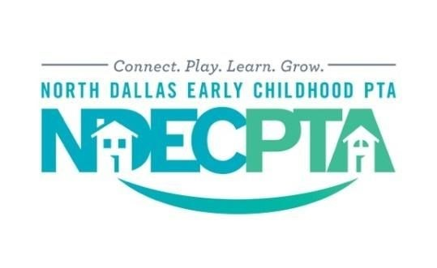
2017­2018 Donor Form

Name of Business:
Contact Person:

Address:

City, State, Zip:

Email Address:

Phone:

I would like offer the following donation:

SPONSORSHIP LEVEL | Sponsor Benefits | One-Time Donation
SILVER | - Business link and logo on NDECPTA.com​ and link in our newsletter (published September 2017-August 2018)  - Promotions may be emailed to the sponsorship chair (ndecptaadvertising@gmail.com) and will be posted on our Facebook page (up to twice a month) | $150
GOLD | - Business link and logo on NDECPTA.com​ and link in our newsletter (published September 2017-August 2018)  - Promotions may be emailed to the sponsorship chair (ndecptaadvertising@gmail.com) and will be posted on our Facebook page (up to twice a month)  - Business logo on the back of our member t­shirts (which are worn at our events in the community and around town) | $250
PLATINUM | - Business link and logo on NDECPTA.com​ and link in our newsletter (published September 2017-August 2018)  - Promotions may be emailed to the sponsorship chair (ndecptaadvertising@gmail.com) and will be posted on our Facebook page (up to twice a month)  - Business logo on the back of our member t­shirts (which are worn at our events in the community and around town)  - Five-minute presentation at one of our monthly meetings or member events | $500

**Please make checks payable to NDECPTA**

Thank you for your continued support for the upcoming 2017­2018 year! Because of our generous sponsors, we are able to continue our mission to make every child's potential a reality by engaging and empowering families and communities to advocate for all children. Feel free to email me with any questions or feedback.

Kaleigh Black​
NDECPTA Sponsorship Chair
ndecptaadvertising@gmail.com

